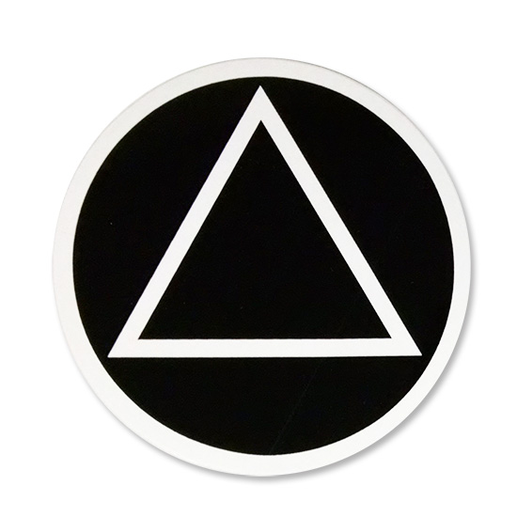
December 23, 2021
THE UNFORTUNATES
Group Conscience Agenda

Call to Order - Serenity Prayer

Roll Call:
GSR — Jeff M.
Treatment — Lorie K.
Treasurer — Joe R.
Secretary — Zach W.
Literature — Adem S.
Corrections — Debbie I.
Coffee Captain — Lisa M.
Hospitality — vacant
Intergroup — Stuart M.
CPC/PI — Cris M.
Chairperson (temp) — Rennie C.
Newcomer Chair — Blake W.

Treasurers Report - Joe R.
Minutes – Zach
GSR Report – Jeff M.
Committee Reports:
- Newcomer Chair
- Hospitality
- Coffee Captain
- CPC/PI
- Treatment
- Corrections
- Literature

Intergroup report –

4th Quarter Intergroup Report
DIA now has a new office manager named Sam F.
Contributions and book sales were higher in this quarter, and DIA is in a healthy cash flow position. Costs were somewhat higher this year related to the move to Farmers Branch, but the DIA has a healthy reserve to absorb these costs.
The Dallas Intergroup Chili Cookoff is scheduled for Feb 25 from 11- 2 and will be held at Cochran Mehtodist church. If you wish to enter the competition, please email Charlie at charlieo42190@yahoo.com.
There are service opportunities available for Zoom meetings at the Dallas County Jail:
Men’s meetings: Monday-Friday 9am-10am, Tuesdays 1pm-2pm.
Women’s meetings:Monday, Wednesday, Friday 12:30pm-1:30pm.
If you would like to volunteer for one of these slots, it can be coordinated through the DIA office, or I will take it to the new Corrections chair when it is announced.
Nightwatch takes phone calls for Intergroup during off hours. This is a great service opportunity that demands little time. You can volunteer to serve as little as one shift a quarter. If you are interested, I can connect you, or you can register online or with the Intergroup office.

Old Business: elections

New Business:

Meeting Adjourn — Close with the Lord’s Prayer

