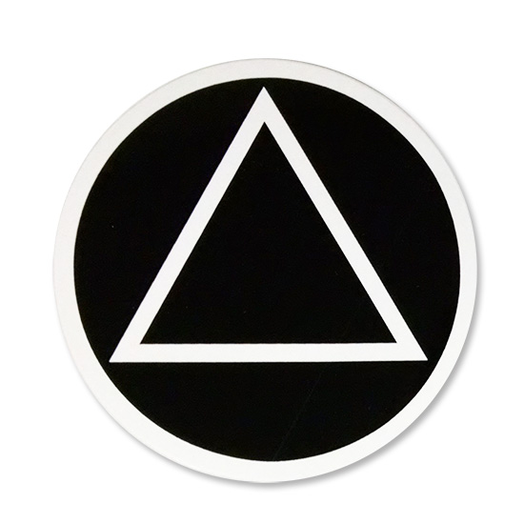
September 23, 2021
THE UNFORTUNATES
Group Conscience Agenda

Call to Order - Serenity Prayer
Roll Call:
GSR — Jeff M.
Treatment — Lori K.
Treasurer — Joe R.
Secretary — Zach W.
Literature — Adem S.
Corrections — Debbie I.
Coffee Captain — Lisa M.
Hospitality — Tracy F.
Intergroup — Stuart M.
CPC/PI — Cris M.
Chairperson (temp) — Rennie C.
Newcomer Chair — Blake W.

Treasurers Report - Joe R.
Minutes – Zach
GSR Report – Jeff M.
Committee Reports:
- Newcomer Chair
- Hospitality
- Coffee Captain
- CPC/PI
- Treatment
- Corrections
- Literature – no report

- Intergroup report –
The Dallas Intergroup office has relocated to 4407 N Beltwood Pkwy, Suite 110 in Farmers Branch.
Contributions and book sales have been down recently and costs higher related to the move. However, DIA has a solid prudent reserve and overall healthy financial position.
The Dallas Intergroup 74th Anniversary is scheduled for September 25 from 1:00 to 4:30pm at Cochran Chapel United Methodist Church at 9027 Midway, near NW Hwy and Midway.
UT Southwestern has an event November 17 & 18 from 2:30pm-4:00pm. Approximately 60 volunteers are needed. Must have a minimum of 3 years sober and be masked. Email Mike D. at mdaymday1@gmail.com if you are interested in volunteering.
Nightwatch takes phone calls for Intergroup during off hours. This is a great service opportunity that demands little time. You can volunteer to serve as little as one shift a quarter. If you are interested, I can connect you, or you can register online or with the Intergroup office.

Old Business: Steering Committee update
New Business:

Meeting Adjourn — Close with the Lord’s Prayer

