Introduction…

- Call to Order — Serenity Prayer

- Roll Call Service Members

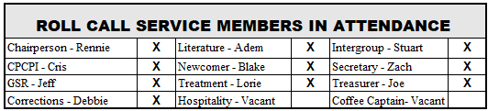

- Reports & Updates -

  - Meeting Minutes - Motion to Approve/2nd

  - GSR
    - District 21 has Open positions – service opportunity at District Level
    - District Meeting – Didn’t meet this month
    - Zoom Fatigue is concern with many groups. Most still have Zoom or Hybrid
    - Update on Financials
    - 74th Anniversary 9/25 1pm-4:30pm
    - Southwest GSO Virtual Forum Oct. 8-10th
    - 5th Addition of Big Book was big topic of Area Conference
    - Special Needs Position is open at the District Level

    - Intergroup Report
    - Office Relocated to Farmer’s Branch Location
    - Intergroup 74th Anniversary
    - Service Opportunity Nov 17-18 UT Southwestern- AA talk to medical students about AA
    - Nightwatch opportunities available to serve. Answer phones overnight

    - Treatment
    - Life Path Zoom meetings Wednesday at 10am is going well
    - Waterford going well, Young Adults are receptive, and more volunteers needed
    - Healing Springs has been unresponsive, so nothing new to report
    - New IOP in Allen would like weekly meeting (open to Zoom) awaiting additional information and formal invitation

  - CP/CPI
    - Routing Notifications to Treatment Chair for volunteer sign-up created

  - Newcomer
    - Everything is going well

  - Corrections
    - Will be able to go back to Collin County soon. Women have coverage can use more support. If interested email Kyle for required documentation. Kyle is taking care of Men’s. Rotating every other week Men/Women (in Person).
  - Hospitality
    - Lacey and Kyle working on prospect for new candidate for Coffee Captain
    - Open Position for Hospitality Chair (Over Coffee Captain & Newcomer Chair)
  - Literature
    - Weekly updates going well, nothing new to report

  - Treasurer’s Report
    - Prudent Reserve normal $3k, set aside another $500 for Hybrid Meetings
    - Q2 contributions $998, $50 for Orange Can
    - 3-month average contributions $77 per week

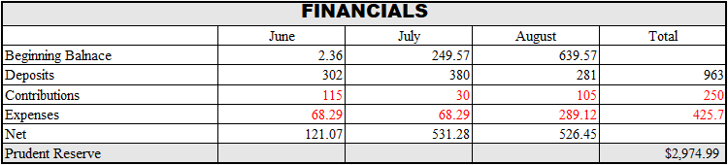

- Old Business

  - Looking at going back to Hybrid in October. Is not feasible at this time. Logistically set up, but need positions filled and ensure is a high enough demand/support for in-person meeting
  - Chair rotation in January - Update.

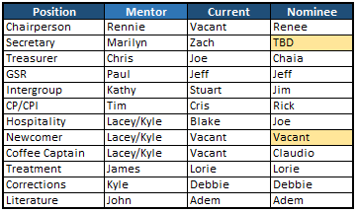

- New Business

- N/A
- *Note from Chair (Please be on camera for Zoom meetings)

- 7th Tradition Venmo Announcement

- Close – Lord’s Payer

